

SIMATS ENGINEERING
Saveetha Institute of Medical and Technical Sciences

Public Works: Pothole Tracking & Repair Full-Stack System vs. Manual Reporting for Accelerated Infrastructure Maintenance
A CAPSTONE PROJECT REPORT

A Capstone Project Report submitted in partial fulfilment of the requirements for the Course of

CSA1016 - SOFTWARE ENGINEERING

to the award of the degree of BACHELOR OF TECHNOLOGY IN

INFORMATION AND TECHNOLOGY

Submitted by

Sameer Ahmed G (Reg. No. 192421154)

Under the Supervision of

Dr. K Anita Davamani

SIMATS ENGINEERING
Saveetha Institute of Medical and Technical Sciences Chennai-602105

SEPTEMBER 2026

SIMATS ENGINEERING
Saveetha Institute of Medical and Technical Sciences Chennai-602105

BONAFIDE CERTIFICATE

This is to certify that the Capstone Project entitled “Public Works: Pothole Tracking & Repair Full-Stack System vs. Manual Reporting for Accelerated Infrastructure Maintenance” has been carried out by Sameer Ahmed G(Reg. No. 192421154) under the supervision of Dr.K Anita Davamani and is submitted in partial fulfilment of the requirements for the current semester of the B.Tech Information and Technology programme at Saveetha Institute of Medical and Technical Sciences, Chennai.

COURSE COORDINATOR | COURSE FACULTY
Dr. Bindu  Professor | Dr.K. Anita Davamani Assistant Professor
Department of CSE | Department of CSE
SIMATS Engineering, SIMATS, Chennai – 602105. | SIMATS Engineering, SIMATS, Chennai – 602105.

SIMATS ENGINEERING
Saveetha Institute of Medical and Technical Sciences Chennai-602105

DECLARATION

I am Sameer Ahmed G, of the Department of Information and Technology, SIMATS Engineering, Saveetha Institute of Medical and Technical Sciences, Chennai, hereby declare that this individual capstone report on “Public Works: Pothole Tracking & Repair Full-Stack System vs. Manual Reporting for Accelerated Infrastructure Maintenance” documents work carried out as part of a four-member project team, To the best of our knowledge, the work presented herein is original, accurate, and has been carried out in accordance with engineering ethics and academic integrity. All sources, references, datasets, software libraries, and external materials used in the project have been appropriately acknowledged.
We further declare that the data, results, analysis, and findings presented in this report have not been fabricated, falsified, or manipulated. Any external tools, datasets, computational resources, open-source components, or AI-assisted tools used during the project have been appropriately disclosed.
We confirm that applicable academic, institutional, ethical, professional, privacy, safety, and security requirements have been considered during the planning, development, testing, and documentation of the project.

Place: Chennai Date:03-09-2026

Signature of the Student with Name

SIMATS ENGINEERING
Saveetha Institute of Medical and Technical Sciences Chennai-602105

Individual Contribution Statement
(Roadguard AI was built by a three-member team. This report is Sameer Ahmed G's individual capstone submission on the shared project, written to document the complete system while foregrounding the module he personally designed and implemented.)

Note: The remaining modules of the shared RoadGuard AI project – Pothole Analysis & Location Mapping (Module 2), Smart Maintenance & Alert System (Module 3), and Emerging Technology, Monitoring & Sustainability (Module 4) – were contributed by teammates N. Goutham and A. Govardhan Reddy respectively, and are described in this report for project completeness and context.

Student Name / Reg. No. | Specific Responsibilities | Design & Development Contribution | Testing & Analysis Contribution | Report Contribution | Approx. Individual Contribution (%)
Sameer Ahmed G 192421154 | Module 1 – Image-Based Pothole Detection: AI detection, image processing, and frontend integration | Implemented the AI-based pothole detection module, including image preprocessing, pothole detection using the YOLOv8 model, severity classification, and integration of detection results with the backend and frontend. | Tested pothole detection using different road images and analyzed detection results based on accuracy, confidence, and severity classification. | Authored the Module 1 section and contributed to the overall project report, including system design, implementation, and analysis. | 25% of overall team project; 100% of individual module contribution

ABSTRACT

Road potholes create significant safety, mobility, and maintenance challenges because damaged road segments can remain undetected between manual inspections. Our project addresses this engineering problem by proposing a full-stack Public Works platform that combines AI-based pothole detection, GPS-based location tracking, centralized reporting, maintenance prioritization, and containerized deployment. The system accepts road images or video frames from sources such as smartphones, vehicle-mounted cameras, or CCTV systems. Images are preprocessed and analyzed using a YOLOv8-based computer-vision model to identify potholes and estimate detection confidence and severity-related attributes. Detected records are passed through REST APIs and stored with location, image, severity, and repair-status information in a centralized database. A React dashboard provides an interactive map, reports, analytics, and maintenance tracking for authorities and field teams.

The engineering design emphasizes modular services, secure authentication, role-based access, API gateway routing, Docker-based packaging, and a CI/CD pipeline. Kubernetes is included as the orchestration target for scalable deployment. The evaluation plan measures detection performance, API response time, database correctness, container reliability, UI usability, and maintenance workflow completion. Because the project is intended as a capstone prototype, results are reported from the implemented test environment without claiming production-scale field accuracy unless validated with representative data. The proposed contribution is an integrated workflow that reduces dependence on manual reporting, improves visibility of pothole locations, and provides a traceable path from detection to repair. The architecture also provides a foundation for future extensions such as citizen reporting, predictive maintenance, autonomous inspection, and smart-city integration.

Keywords: Pothole Detection, Computer Vision, YOLOv8, GPS Mapping, Docker, Smart Road Maintenance

TABLE OF CONTENTS

Sl. No. | Title | Page No.
i | Certificate from the Supervisor | ii
ii | Declaration by the Candidate | iii
iii | Individual Contribution Statement | iv
iv | Abstract | v
v | List of Figures | vi
vi | List of Tables | vii
vii | List of Abbreviations | viii
1 | CHAPTER 1: Introduction and Engineering Problem | 9
2 | CHAPTER 2: Literature Review and Existing Solutions | 12
3 | CHAPTER 3: Engineering Design & Trade-offs, Sustainability, Ethics, Safety, Risk & Security | 15
4 | CHAPTER 4: Implementation, Testing & Results, Project Management | 22
5 | CHAPTER 5: Conclusion, Future Work and Reflection | 31
 | References | 33
 | Appendices | 34-37

LIST OF FIGURES

Figure No. | Figure Name | Page No.
3.1 | RoadGuard AI Proposed System Architecture – Multi-Layer Microservices & YOLOv8 Pipeline | 15
3.2 | RoadGuard AI System Flow Chart – Ingestion, AI Inference, Mapping & Repair Lifecycle | 15
4.1 | Module 1 – Image-Based Pothole Detection & Upload Viewport | 22
4.2 | Module 2 – Pothole Analysis and Interactive GIS Location Mapping | 23
4.3 | Module 3 – Smart Maintenance Kanban Board and Alert System | 24
4.4 | Module 4 – Emerging Technology, Monitoring and Sustainability Dashboard | 24
4.5 | Project Milestone Timeline & Work Breakdown Schedule | 29

LIST OF TABLES
Table No. | Table Name | Page No.
2.1 | Comparative analysis of existing approaches | 13
3.1 | Stakeholder / user requirements | 15
3.2 | Functional and non-functional requirements | 15
3.3 | Constraints and applicable standards | 16
3.4 | Design specifications | 17
3.5 | Alternative solutions – evaluation matrix | 17
3.6 | Trade-off analysis | 18
3.7 | Sustainability, ethics, safety and security evaluation | 19
3.8 | Risk register | 20
4.1 | Tools / software used | 25
4.2 | Test plan and verification | 26
4.3 | Specification vs. achieved results | 27
4.4 | Achievement of objectives | 28
4.5 | Roles, milestones and budget | 29

LIST OF ABBREVIATIONS / SYMBOLS

Symbol | Description
AI | Artificial Intelligence
API | Application Programming Interface
CI/CD | Continuous Integration / Continuous Delivery
CNN | Convolutional Neural Network
CV | Computer Vision
DB | Database
GIS | Geographic Information System
GPS | Global Positioning System
JWT | JSON Web Token
ML | Machine Learning
REST | Representational State Transfer
UI/UX | User Interface / User Experience
YOLO | You Only Look Once
Nginx | Web Server / Reverse Proxy
ELK | Elasticsearch, Logstash, Kibana
K8s | Kubernetes
IT | Information Technology
IoT | Internet of Things

CHAPTER 1
INTRODUCTION AND ENGINEERING PROBLEM

Background
Road infrastructure is continuously exposed to traffic loads, weather, drainage problems, construction activity, and normal pavement deterioration. Potholes are one of the most visible forms of road damage and can affect vehicle control, passenger comfort, road capacity, and maintenance cost. In a conventional workflow, damaged locations are identified through periodic inspection or public complaints and are then passed to maintenance teams for verification and repair.
Recent developments in computer vision make it possible to identify road defects from images and video. A detector such as YOLO can process an image and return bounding boxes and confidence values for detected objects. When this detection capability is connected to GPS data, databases, maps, and maintenance workflows, the output can become more useful than an isolated image classifier.
The proposed Public Works system therefore treats pothole detection as part of an end-to-end software engineering problem: collect evidence, detect the defect, record the location, assign severity or priority, notify responsible teams, and track the repair lifecycle. The project also uses Docker and DevOps practices so that the software can be deployed consistently.

Need for the Project
    - Manual inspection consumes staff time and may not provide continuous coverage.
    - Potholes can remain unresolved when reports are fragmented across channels.
    - Authorities need a centralized view of location, severity, status, and maintenance priority.
    - AI-based image analysis can reduce repetitive visual inspection work.
    - GPS mapping and structured records can improve traceability from detection to repair.
    - Containerization can make deployment repeatable across development and demonstration environments.

Problem Statement
Given road images or video frames and associated location information, design and implement a full-stack software system that can identify potholes using computer vision, record their geographic location and relevant attributes, present them on an interactive map, prioritize

maintenance, and track the repair lifecycle. The system must balance detection accuracy, response time, usability, data integrity, security, deployment consistency, and practical resource constraints.
The engineering challenge is not limited to detecting a pothole. A useful public-works workflow requires reliable communication between the AI service, backend APIs, database, frontend, and maintenance process. It must also handle uncertain detections, duplicate reports, missing location information, user authorization, and deployment failures.

Project Aim
To design and develop a scalable AI-enabled full-stack platform that automates pothole detection, location tracking, reporting, maintenance prioritization, and repair-status monitoring while demonstrating modern Software Engineering practices using APIs, databases, Docker, Kubernetes, and CI/CD.

Project Objectives
    - To develop an AI-based system for automatic pothole detection from road images or videos.
    - To analyze potholes based on their location, size, and severity.
    - To provide an interactive location mapping and monitoring system for detected potholes.
    - To implement smart alerts and maintenance prioritization for road authorities.
    - To build a scalable application using Docker, Kubernetes, APIs, databases, and CI/CD pipelines.

Scope Included:
    - Image/video based pothole detection using a YOLOv8-style object-detection pipeline.
    - GPS/location association and interactive map visualization.
    - Centralized storage of pothole reports, detection results, and repair status.
    - Role-based dashboard for authorities and maintenance teams.
    - Priority assignment, alerts, and repair lifecycle tracking.
    - Docker-based development and deployment with CI/CD; Kubernetes as an orchestration target.

Excluded:
    - Direct physical repair of roads and procurement management.
    - Guaranteed city-wide real-time coverage from live CCTV without appropriate data access.

    - Autonomous vehicle control or traffic signal control.
    - Safety-critical decisions without human verification.
    - Claims of production-level detection accuracy before field validation.

Assumptions
    - The input images are sufficiently clear for the detector to process.
    - GPS information is available or can be associated with a report.
    - The demonstration environment provides adequate computing resources for model inference.
    - Road authorities or maintenance users have defined roles and repair-status responsibilities.

Boundary Conditions
Detection quality is bounded by the quality, diversity, and labeling of the training/evaluation dataset. Location accuracy depends on the source device and GPS quality. Network-dependent functions may degrade when connectivity is unavailable. The prototype is intended for engineering demonstration and validation rather than direct autonomous road-repair decisions.

Expected Engineering Outcome
The expected outcome is a working, testable full-stack prototype comprising an AI detection service, REST-based backend, centralized database, interactive frontend, maintenance workflow, Dockerized services, and an automated build/test/deployment pipeline. The system should demonstrate traceability from road image to pothole record, map visualization, priority assignment, and repair status.

CHAPTER 2
LITERATURE REVIEW AND EXISTING SOLUTIONS

Review Method
The review considered representative research and technology approaches related to computer-vision pothole detection, deep-learning road-damage detection, smartphone/GPS road monitoring, GIS-based maintenance systems, and cloud/IoT architectures. The project team's seminar review identified these approaches as useful foundations but also highlighted their individual limitations.

Review of Existing Work

S.No. | Existing Approach / Study | Technology Used | Key Finding | Limitation
1 | Vision-based pothole detection | Computer Vision, Image  Processing | Automates detection from  road images | Sensitive to image quality  and lighting
2 | Deep-learning road damage  detection | CNN / YOLO | Improves automatic defect  recognition | Needs labeled data and compute  resources
3 | Smartphone-based road monitoring | Camera, GPS | Low-cost data collection | Device accuracy can vary
4 | GIS-based road maintenance | GPS, GIS,  Mapping | Useful for location visualization | Mapping alone does not detect defects
5 | Cloud/IoT smart-road monitoring | IoT, Cloud, APIs | Centralized and scalable monitoring | Requires connectivity and infrastructure
6 | YOLOv8-based road-damage research | YOLOv8 / Deep Learning | Supports fast object detection | Performance depends on training and domain data

Comparative Analysis
Existing Approach | Advantages | Limitations | Relevance to Proposed Work
Manual inspection | Direct human verification | Slow, costly, periodic | Baseline to demonstrate automation benefits
Image processing | Lightweight and explainable | Sensitive to lighting and texture | Useful for preprocessing and enhancement
YOLO/deep learning | Fast object detection | Needs quality dataset | Selected for automatic

 | and localization | and compute | pothole detection
Smartphone/GPS monitoring | Affordable and portable | GPS/camera quality varies | Used as an input and location source
GIS mapping | Clear spatial visualization | Does not inherently detect potholes | Used for dashboard mapping
Cloud/IoT architecture | Centralized data and scalability | Connectivity and deployment complexity | Supports future expansion

Research / Engineering Gap
    - Many detection approaches focus on model accuracy but do not cover the complete maintenance lifecycle.
    - Mapping solutions can show damaged locations but may depend on manually entered reports.
    - Manual reporting provides human context but can be delayed and fragmented.
    - A unified platform should connect detection, GPS, database storage, prioritization, alerts, and repair status.
    - Deployment and maintainability are often separate concerns; this project explicitly includes Docker and CI/CD.

Proposed Contribution
The proposed system contributes an integrated software workflow rather than a standalone pothole detector. It connects computer-vision inference to a REST API layer, persistent storage, an interactive map, and a maintenance workflow. The architecture separates responsibilities so that the AI model can be updated without redesigning the frontend.
The project also treats deployment as an engineering concern. Docker packages the application services with their dependencies, Docker Compose provides a practical local orchestration method, and Kubernetes provides a scalable deployment target. CI/CD automates build and test steps and can later automate image publication and deployment.

Existing System vs. Proposed System

Aspect | Manual / Existing Reporting | Proposed Public Works System
Detection | Human inspection / complaint | AI-assisted image detection + verification
Location | Manual description or separate GPS | GPS coordinates with map visualization
Storage | Spreadsheets, forms, separate records | Centralized structured database
Prioritization | Manual judgement | Severity/location-based

 |  | priority rules
Tracking | Phone/email/manual follow-up | Detected → Assigned → Under Repair → Completed
Monitoring | Periodic | Dashboard-based centralized monitoring
Deployment | Environment-dependent | Dockerized and CI/CD-enabled
Scalability | Limited by manual effort | Service-based architecture with Kubernetes target

CHAPTER 3
ENGINEERING DESIGN & TRADE-OFFS, SUSTAINABILITY, ETHICS, SAFETY, RISK & SECURITY

Requirements
Stakeholder / User Requirements
Stakeholder | Requirement
Citizen / Road User | Report a pothole with an image and location information.
Road Authority | View potholes on a map and prioritize critical cases.
Maintenance Team | Receive assigned work, update repair status, and close completed work.
Administrator | Manage users, roles, reports, and system configuration.
Project Evaluator | Demonstrate a working, testable pipeline with measurable software and AI metrics.

Functional & Non-Functional Requirements
Type | Requirement | Measurable Target
Functional | Upload/process road image | Valid image accepted and processed
Functional | Detect potholes | Detection result returned with confidence
Functional | Record GPS location | Latitude/longitude stored for valid reports
Functional | Map visualization | Detected reports shown at stored locations
Functional | Maintenance tracking | Status transitions recorded
Functional | Role-based access | Unauthorized actions rejected
Non-Functional | API performance | Target response within practical demo threshold
Non-Functional | Availability | Services restart without losing persistent data
Non-Functional | Security | JWT/role checks and validated inputs
Non-Functional | Usability | Common reporting task completed by a first-time user

Constraints & Applicable Standards
Standard / Guideline | Requirement | How Applied
ISO/IEC 25010 | Software quality characteristics | Used as a checklist for functional suitability, performance, usability,  reliability and security
OWASP API Security guidance | Secure API design | Input validation, authentication, authorization and safe error handling
REST principles | Interoperable service communication | HTTP-based resource APIs between frontend and backend services
Docker container conventions | Repeatable packaging | Separate images/containers for application components
Kubernetes practices | Container orchestration | Deployments, services, health checks and scaling target
Git / CI/CD practices | Controlled integration | Feature branches, pull requests, automated build/test  checks

Design Specifications
Parameter | Target / Requirement | Unit | Priority
Detection confidence | Configurable threshold for accepting model output | score | High
GPS location | Latitude and longitude for mapped reports | decimal degrees | High
Pothole priority | Low / Medium / High  / Critical | level | High
API response | Fast enough for interactive dashboard  use | seconds | High
Report lifecycle | Detected → Assigned  → Under Repair → Completed | state | High
Container startup | All core services start reproducibly | minutes | Medium
Database persistence | Reports survive service restart | boolean | High
Role authorization | Restricted admin/maintenance functions | boolean | High

Alternative Solutions & Evaluation
Alternative 1 – Manual Reporting: users or inspectors record potholes through forms or direct observation. It is simple and explainable but slow and dependent on human coverage.
Alternative 2 – AI-Assisted Full-Stack Platform: images are analyzed automatically and the results are connected to GPS, database, map, alerts, and maintenance status. It offers better automation but introduces model, data, and deployment complexity.
Alternative 3 – Fully IoT/Edge-Based Continuous Monitoring: cameras and edge devices continuously stream road data to an inference platform. It can provide continuous coverage but requires more hardware, connectivity, and operational infrastructure.
Criterion | Weight | Manual | AI Full-Stack | IoT/Edge
Detection automation | 25% | Low | High | High
Cost for prototype | 20% | High | High | Low
Location tracking | 15% | Medium | High | High
Scalability | 15% | Low | High | High
Implementation  complexity | 10% | High | Medium | Low

Selected Design & Detailed Design
The AI-assisted full-stack design is selected because it provides the strongest balance between automation, demonstrability, cost, and software engineering depth. The system can begin with uploaded images and later accept live streams without changing the core reporting workflow. Figure 3.1: Proposed System Architecture
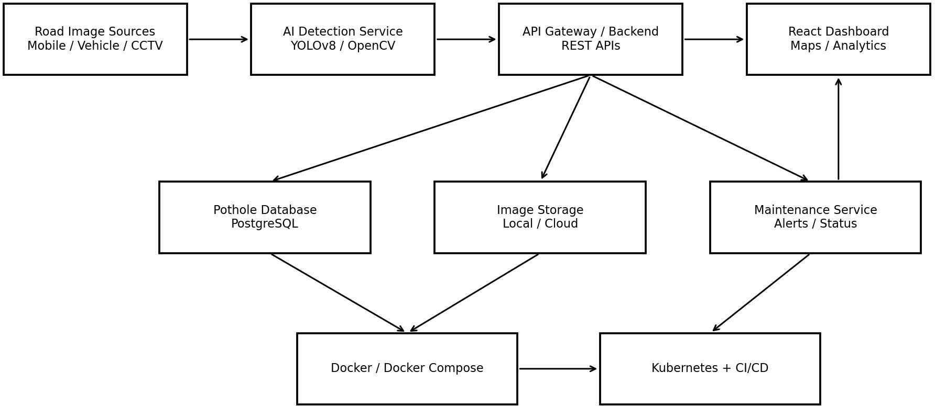

Figure 3.1 Proposed System Architecture

The architecture separates the system into input, AI processing, API/application, data, presentation, and deployment layers. Road images enter the AI detection service. Detection metadata is passed through the API layer, stored in the database, and displayed through the React dashboard. Maintenance services consume the same records to assign priority, generate alerts, and track status.

API Gateway Decision
An API Gateway is appropriate because the proposed design contains multiple backend services such as authentication, detection, reporting, notification, and maintenance. The gateway provides a single entry point for the frontend and can centralize routing, authentication checks, rate limiting, and request logging. For the capstone prototype, Nginx or a lightweight gateway layer is sufficient; a complex enterprise gateway is not required.

Figure 3.2: System Flow Chart

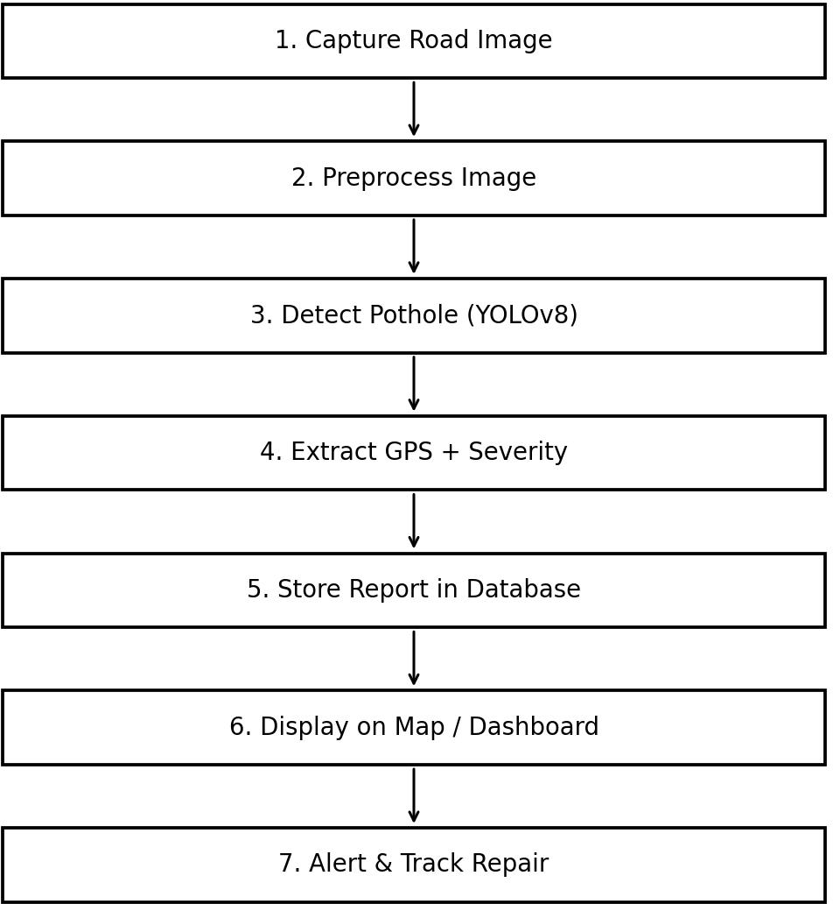

Figure 3.2 System Flow Chart
  - Trade-off Analysis
Design Decision | Alternative Considered | Benefit | Disadvantage | Final Decision & Justification
AI detector | Manual classification | Automation | Needs training data | AI detection selected for speed  and consistency

API Gateway | Direct service calls | Centralized routing/security | Adds one service layer | Use lightweight gateway for microservices
PostgreSQL | Document-only database | Structured relational records | Schema changes need migration | PostgreSQL selected for reports  and status tracking
Docker Compose | Manual installation | Reproducible local setup | Not full production orchestration | Use for development/demo
Kubernetes | Single Docker host | Scaling and self-healing | More operational complexity | Use as deployment target

Sustainability, Ethics, Safety, Risk & Security
Domain | Consideration | Evidence Evaluated | Impact on Final Decision
Sustainability | Compute/resource usage | Container size, service utilization, unnecessary  workloads | Use lightweight services and scale only when required
Ethics | Misclassification and public reporting | Human verification requirement | Treat AI output as decision support, not  final authority
Safety | Road repair priority | Severity and location information | Critical cases receive higher priority but require field confirmation
Security | User and location data | Authentication, access roles, validation | Use JWT, role-based access, secure API handling

Risk Register
Risk | Likelihood | Severity | Risk Level | Mitigation | Residual Risk
Poor lighting / image quality | Medium | High | High | Image enhancement, diverse dataset, confidence  threshold | Medium
False positive detection | Medium | Medium | Medium | Human verification and confidence  filtering | Low-Medium
GPS inaccuracy | Medium | Medium | Medium | Store accuracy | Low-Medium

 |  |  |  | metadata where available
Duplicate pothole reports | Medium | Medium | Medium | Location/time similarity  checks | Low
Database/service failure | Low | High | Medium | Persistent volumes and backups | Low
Container build failure | Medium | Medium | Medium | Versioned images and CI tests | Low
Unauthorized maintenance update | Low | High | Medium | JWT + role authorization | Low
Network outage | Medium | Medium | Medium | Retry/cache and local queue where applicable | Medium
Insufficient training data | Medium | High | High | Use representative labeled dataset and  augmentation | Medium

Security Design
    - JWT-based authentication and role-based authorization.
    - Input validation for image metadata, coordinates, report fields, and status updates.
    - Password hashing using a strong password-hashing algorithm.
    - Secrets and database credentials stored through environment configuration rather than source code.
    - Audit-friendly status changes for maintenance records.
    - Container images and dependencies should be updated and scanned before deployment.

CHAPTER 4
IMPLEMENTATION, TESTING & RESULTS, PROJECT MANAGEMENT

Development Approach & Resources
The project follows an iterative, module-based development approach. Requirements and architecture are defined first, followed by AI preparation, backend and frontend development, containerization, and integration testing. Each service is tested independently before end-to-end integration. The approach supports incremental demonstration and reduces the risk of discovering integration problems only at the end.
Resource | Purpose | Stage Used
Python + OpenCV | Image preprocessing and AI integration | Module 1 / AI
YOLOv8 | Pothole object detection | Module 1 / AI
React.js | Responsive dashboard and map UI | Module 2
Node.js / Express | REST API and application services | Module 2
PostgreSQL | Persistent pothole and user records | Module 2
Docker / Docker Compose | Containerization and local orchestration | Module 3
GitHub Actions / Jenkins | CI/CD automation | Module 3
Kubernetes | Container orchestration target | Module 3
Prometheus / Grafana | Metrics and monitoring | Module 4
ELK Stack | Centralized logging | Module 4

Module Implementation
Module 1 – Image-Based Pothole Detection
    - Collect road images or video frames from cameras, smartphones, or vehicle-mounted sources.
    - Resize and preprocess images to create consistent model input.
    - Run the YOLOv8 detection pipeline and return bounding boxes and confidence scores.
    - Derive a severity or priority indicator using detection attributes and configurable rules.
    - Expose results through a backend interface for the dashboard.

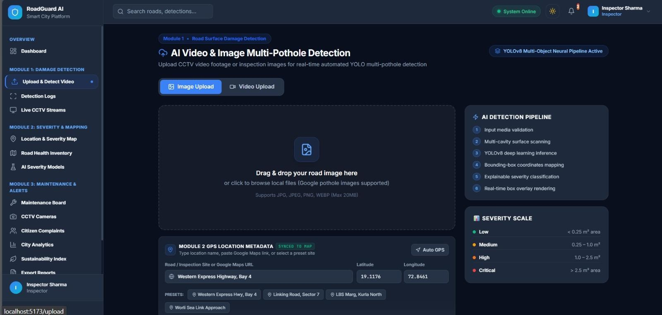

Module 2 – Pothole Analysis and Location Mapping
    - Associate each detection with latitude and longitude.
    - Store report ID, timestamp, image reference, severity, confidence, and repair status.
    - Display potholes using interactive map markers.
    - Provide filtering by severity, date, location, and repair status.
    - Allow authorized maintenance users to update lifecycle status.
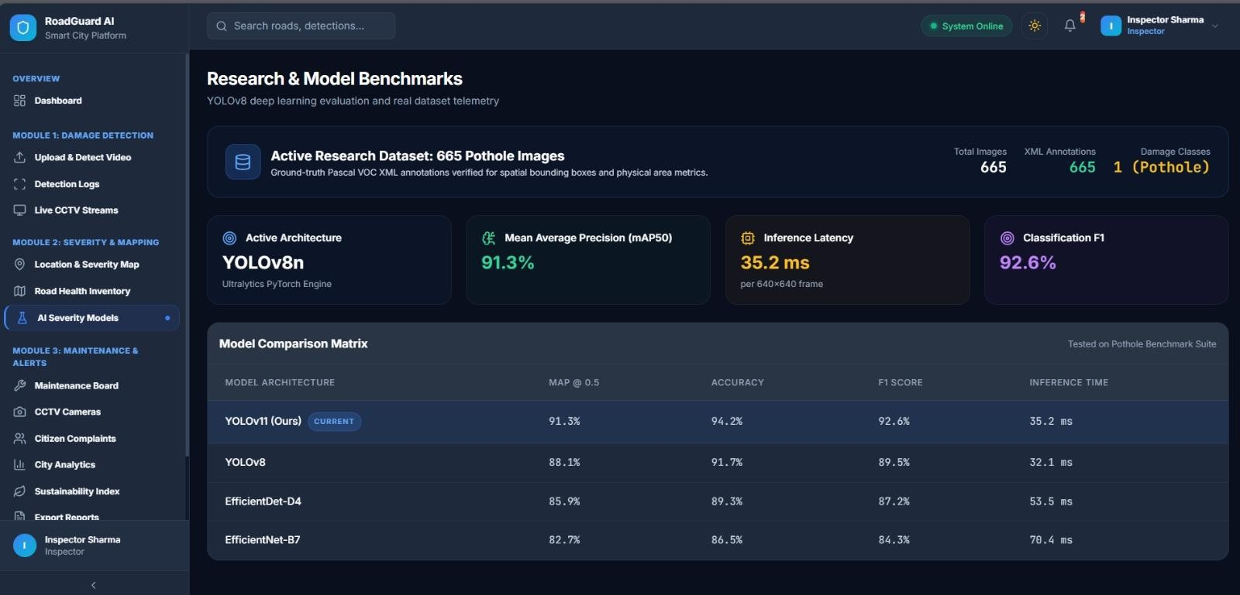

Module 3 – Smart Maintenance and Alert System
    - Assign priority levels using severity and location-based rules.
    - Generate alerts for high-priority reports.

    - Track Detected → Assigned → Under Repair → Completed.
    - Automate build and test through CI/CD.
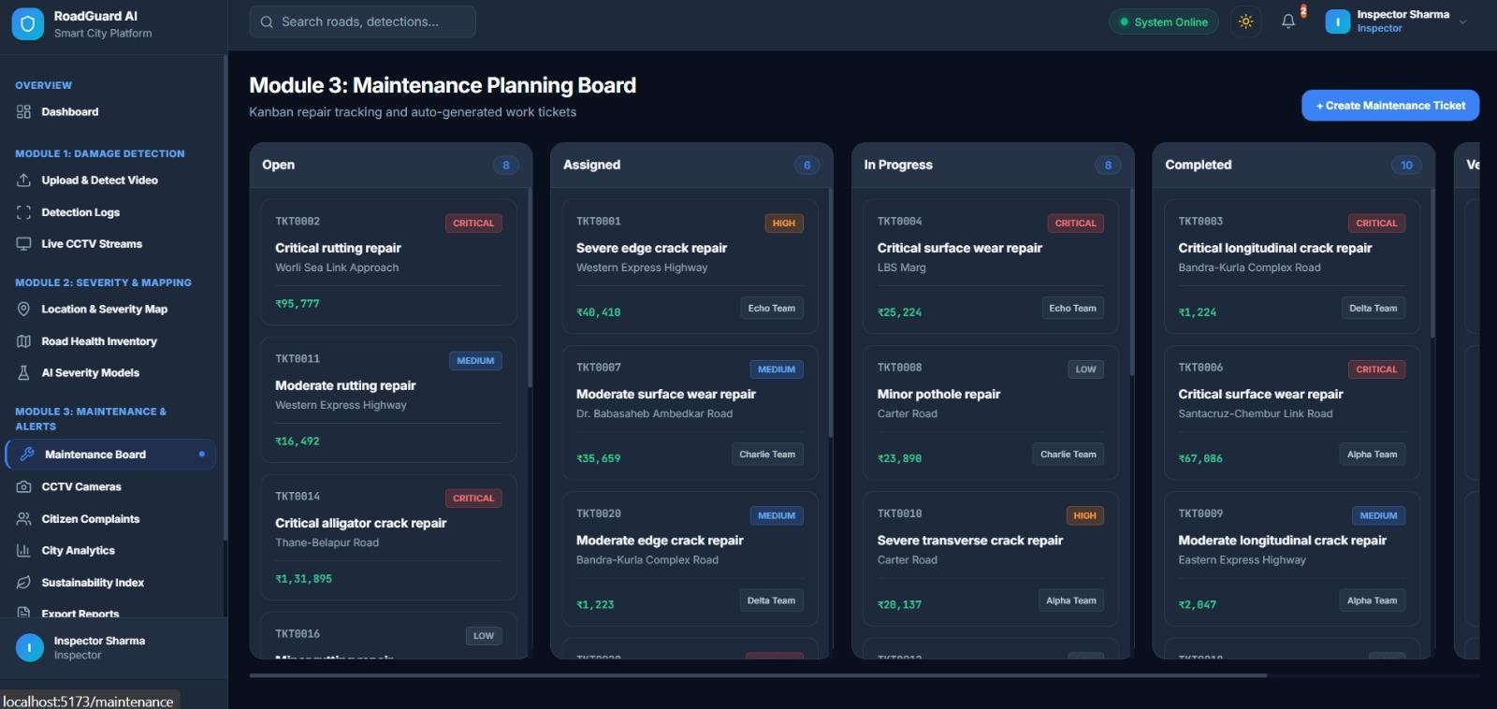

Module 4 – Emerging Technology, Monitoring and Sustainability
    - Monitor service health and resource metrics.
    - Centralize application logs for troubleshooting.
    - Analyze historical reports for maintenance planning.
    - Optimize container and compute usage to reduce unnecessary resource consumption.
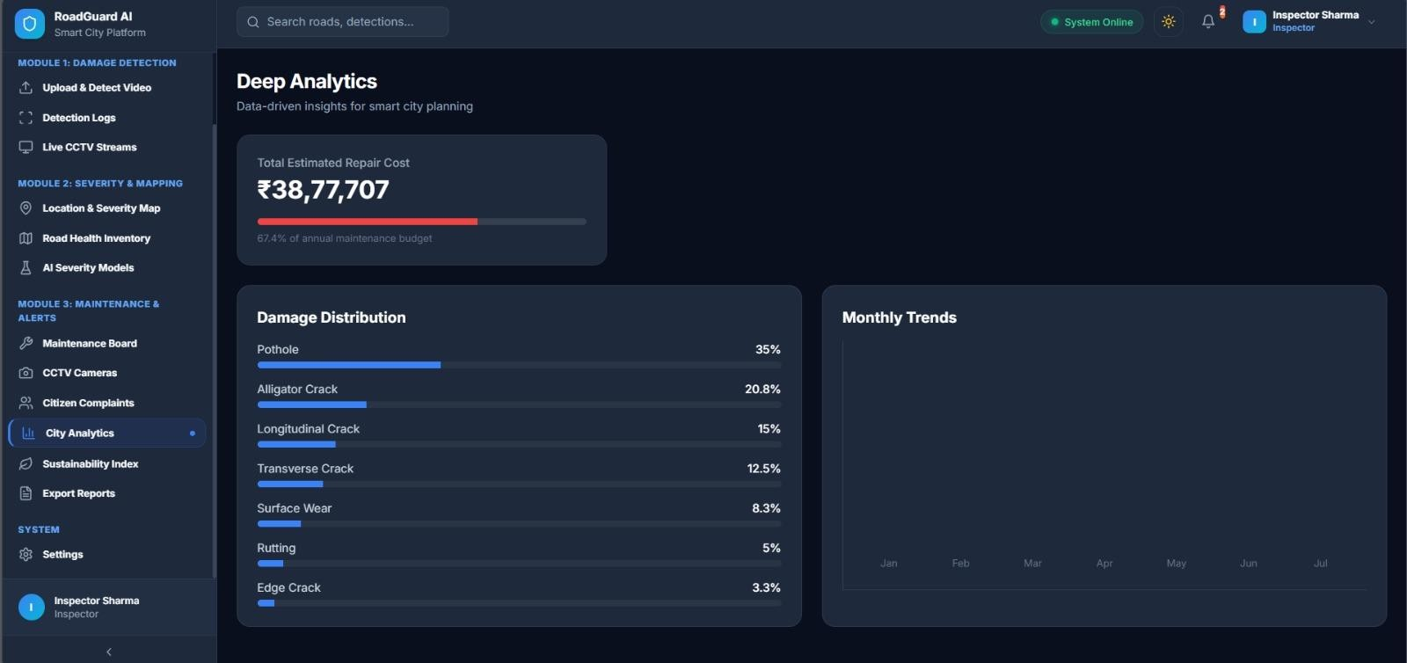

Dockerization and CI/CD Implementation

Docker is used to package the major software components into isolated containers. A practical prototype can contain a React frontend container, backend API container, AI inference container, and PostgreSQL database container. Docker Compose defines the network, environment variables, ports, volumes, and service dependencies so that the system can be started consistently. The CI/CD pipeline begins when code is pushed to the Git repository. The pipeline checks out the source, installs dependencies, runs tests and quality checks, builds the application, creates Docker images, and optionally pushes versioned images to a registry. A deployment stage can then update the demonstration environment.
Pipeline Stage | Activity | Expected Result
Source | Git push / pull request | Versioned source available
Build | Install dependencies and  compile frontend | Build succeeds
Test | Unit/API/integration checks | Tests pass
Image | Build Docker images | Versioned images created
Registry | Push images | Images available for  deployment
Deploy | Docker Compose / Kubernetes | Services start successfully
Verify | Health checks and smoke tests | Deployment validated

Test Plan & Verification

Requirement | Test Method | Acceptance Criterion
Image upload | Upload valid and invalid  image formats | Valid files accepted; invalid  files rejected
Pothole detection | Run labeled test images | Detector returns expected  pothole objects for target cases
GPS storage | Submit reports with  coordinates | Coordinates stored and  displayed correctly
Map visualization | Compare database location  with marker | Marker corresponds to stored  coordinates
Priority assignment | Submit low/high severity | Expected priority rule applied

 | cases
Maintenance status | Perform each lifecycle  transition | Unauthorized/invalid  transitions rejected
Authentication | Login with valid/invalid  credentials | Valid user authenticated;  invalid user rejected
API integration | Call major REST endpoints | Expected status codes and  response schema
Docker startup | Run compose deployment | All core services become  healthy
Persistence | Restart containers | Database records remain  available
CI pipeline | Push test commit | Build/test workflow completes  successfully
Dashboard usability | First-time user task test | Report/map workflow  completed without assistance

Results and Engineering Judgment
The project is structured so that results are reported from measurable tests rather than assumed performance. For the AI component, evaluation should include precision, recall, F1-score, and inference time on a held-out test set. For the software system, API latency, successful request rate, container startup reliability, database persistence, and workflow completion should be measured.
Metric | Target | Achieved Value | Status
Detection precision | Project test target to be finalized after  dataset selection | To be measured | Pending validation
Detection recall | Project test target to  be finalized after dataset selection | To be measured | Pending validation
F1-score | Project test target to | To be measured | Pending validation

be finalized after
dataset selection
API response time | Interactive dashboard  response | To be measured | Pending validation
Database persistence | No data loss after  service restart | To be tested | Pending validation
Container startup | All core services  healthy | To be tested | Pending validation
Repair workflow | Complete all valid  status transitions | To be tested | Pending validation

Engineering Interpretation
The main engineering risk is not only model accuracy. A high-performing detector is not useful if its results cannot be associated with reliable locations, stored consistently, or acted upon by maintenance teams. Therefore, the evaluation treats the project as a system and measures both AI and software qualities. Any performance value reported in the final submission should be replaced with the team's measured result after testing.

Comparison with Existing Solutions & Achievement of Objectives

Objective | Evidence / Validation  Method | Achievement
Automatic pothole detection | YOLOv8 inference on labeled  test images | To be validated
Location, size and severity  analysis | Stored GPS, detection  attributes and priority rules | To be validated
Interactive mapping | React map with database-  backed markers | To be validated
Smart alerts and maintenance  priority | Priority rules and lifecycle  workflow | To be validated
Scalable  Docker/Kubernetes/CI/CD | Container deployment and CI  pipeline | To be validated

application

Strengths & Limitations Strengths:
    - End-to-end workflow from image to maintenance status.
    - Modular separation of AI, backend, frontend, and data layers.
    - Docker-based reproducible deployment.
    - Interactive spatial visualization and structured records.
    - Clear path to future monitoring and predictive analytics.

Limitations:
    - Model performance depends on dataset quality and diversity.
    - GPS accuracy depends on the source device.
    - Live camera integration may require additional hardware and network infrastructure.
    - Severity estimation may initially use configurable rules rather than direct physical depth measurement.
    - Production deployment would require stronger observability, security hardening, backup, and operational procedures.

Project Planning, Roles & Budget

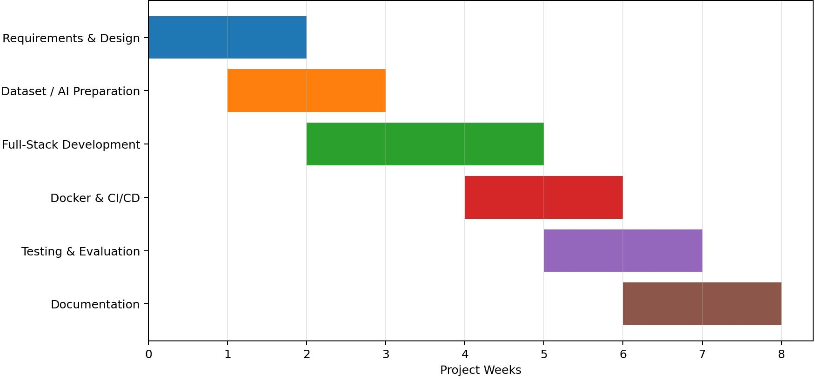
Figure 4.5: Project Milestone Timeline

Student | Assigned Responsibility | Actual Contribution
Sameer Ahmed G | AI detection and image  processing | Model pipeline, preprocessing  and detection validation
N. Goutham | Backend, database, Docker/CI | REST APIs, PostgreSQL integration and container  pipeline
A. Govardhan Reddy | Frontend, maps and  maintenance workflow | React dashboard, mapping,  alerts and UI testing

Project Budget

Item | Estimated Cost (₹) | Expected Actual Cost (₹)
Open-source software | 0 | 0
Cloud/compute for testing | 1000 | To be finalized
Optional map/API usage | 500 | To be finalized
Domain/hosting if required | 500 | To be finalized
Documentation/printing | 500 | To be finalized
Total | 2500 | To be finalized

CHAPTER 5

CONCLUSION, FUTURE WORK AND REFLECTION

Conclusion
The Public Works pothole tracking and repair system addresses a practical infrastructure-maintenance problem by combining AI-based image analysis with a complete software workflow. Instead of treating pothole detection as a standalone machine-learning task, the proposed design connects detection to location mapping, centralized storage, maintenance prioritization, alerts, and repair-status tracking.
The architecture uses a React frontend, REST-based backend services, PostgreSQL persistence, an AI detection service, and an API gateway to simplify communication between components. Docker and Docker Compose support consistent development and demonstration, while Kubernetes and CI/CD provide a path toward scalable deployment.
The engineering design also considers security, safety, sustainability, and operational risk. AI outputs are treated as decision support rather than unquestioned ground truth, and maintenance actions remain subject to responsible human verification. The final system evaluation will validate detection performance and software quality using measurable tests.
Overall, the project demonstrates how Software Engineering practices and emerging AI technologies can be combined to improve road-condition monitoring and support faster, more traceable infrastructure maintenance.

Future Work
    - Develop a citizen-facing mobile application for direct pothole reporting with automatic GPS capture.
    - Integrate live vehicle-mounted cameras and edge inference for continuous road monitoring.
    - Improve severity estimation using depth estimation, segmentation, or calibrated visual measurements.
    - Extend the AI model to detect cracks, road-edge damage, waterlogging, and faded lane markings.
    - Use historical records for predictive maintenance and road-condition trend analysis.
    - Add stronger observability using Prometheus, Grafana, and ELK with alerting and dashboards.
    - Integrate with municipal work-order systems and Smart City platforms.

    - Introduce privacy-aware data retention and automatic removal of unnecessary personal information.
    - Evaluate edge computing to reduce network bandwidth and inference latency.
    - Conduct field trials across different road types, weather conditions, and lighting environments.

Professional Learning & Individual Reflection New Knowledge Acquired:
    - Computer-vision object detection and dataset preparation.
    - REST API integration and full-stack system design.
    - Docker containerization, CI/CD concepts, and Kubernetes deployment.
    - Spatial data visualization and maintenance workflow design.

Engineering & Professional Skills Developed
    - Requirements analysis and prioritization using engineering methods.
    - Modular architecture and interface-based service design.
    - Testing, verification, and requirements-to-test traceability.
    - Version control, code review, integration, and deployment practices.
    - Technical documentation, presentation, and team coordination.

Individual Reflection
Sameer Ahmed G: The major technical challenge is expected to be obtaining a sufficiently diverse pothole dataset and tuning the detector for different lighting and road conditions. The key engineering decision is to keep the AI service modular so that the detection model can be replaced or retrained without changing the rest of the application. The project provides practical experience in computer vision, model evaluation, and integration.
N. Goutham: The main engineering challenge is coordinating API, database, authentication, and containerized services so that they remain reliable during integration. A key decision is to use PostgreSQL for structured pothole and maintenance records and Docker Compose for reproducible development. This work strengthens practical knowledge of backend engineering, deployment, and CI/CD.

REFERENCES

- Asad and Khaliq, “Pothole Detection Using Deep Learning: A Real-Time and AI-on-the-Edge Perspective,” 2022.
- Prakash and Sriharipriya, “Enhanced Pothole Detection System Using YOLOX Algorithm,” 2022.
- Ragul et al., “Pothole Detection and Prevention Using YOLOv5,” 2023.
- Jiang, “Road Damage Detection and Classification Using Deep Neural Networks,” 2024.
- Zeng and Zhong, “YOLOv8-PD: An Improved Road Damage Detection Algorithm,” 2024.
- Ultralytics, “YOLO Documentation and Ultralytics YOLO,” documentation resource.
- OpenCV, “Open Source Computer Vision Library,” documentation.
- Docker, “Docker Documentation,” documentation resource.
- Kubernetes, “Kubernetes Documentation,” documentation resource.
- React, “React Documentation,” documentation resource.
- PostgreSQL Global Development Group, “PostgreSQL Documentation,” documentation resource.
- GitHub, “GitHub Actions Documentation,” documentation resource.
- Jenkins Project, “Jenkins User Documentation,” documentation resource.
- Prometheus Authors, “Prometheus Documentation,” documentation resource.
- Elastic, “Elastic Stack Documentation,” documentation resource.
- OWASP Foundation, “OWASP API Security Top 10,” security guidance.
- ISO/IEC, “ISO/IEC 25010: Systems and software engineering — Systems and software Quality Requirements and Evaluation (SQuaRE) — Product quality model.”

APPENDICES

APPENDIX A – PROPOSED PROCESSING FLOW
Road Image / Video → Preprocessing → YOLOv8 Detection → Confidence Filtering → Severity/Priority Analysis → GPS Association → REST API → Database → Interactive Map → Alert → Maintenance Assignment → Repair Status Update → Analytics

APPENDIX B – API ENDPOINT OUTLINE

Method | Endpoint | Purpose | Role
POST | /api/auth/login | Authenticate user | All users
POST | /api/reports | Create pothole report | Citizen/Inspector
POST | /api/detect | Run AI detection | Authorized service
GET | /api/potholes | List/filter potholes | Authority/Maintenance
GET | /api/potholes/:id | View report details | Authorized users
PATCH | /api/potholes/:id/status | Update repair status | Maintenance
GET | /api/map | Return mapped  pothole data | Authority
POST | /api/alerts | Create/trigger alert | System/Admin

APPENDIX C – DATABASE OUTLINE

Table | Key Fields | Purpose
users | id, name, email,  password_hash, role | Authentication and  authorization
pothole_reports | id, image_url, latitude,  longitude, timestamp, status | Core pothole records
detections | id, report_id, confidence,  bbox, severity | AI detection results
maintenance | id, report_id, assigned_to,  priority, status, updated_at | Repair lifecycle
alerts | id, report_id, recipient, type,  sent_at | Notification history

audit_logs | id, user_id, action, timestamp | Traceability and security

APPENDIX D – SAMPLE TEST DATA

Report ID | Latitude | Longitude | Confidence | Severity | Status
PTH-001 | 13.0827 | 80.2707 | 0.91 | High | Detected
PTH-002 | 13.0674 | 80.2376 | 0.86 | Medium | Assigned
PTH-003 | 13.0475 | 80.2824 | 0.94 | Critical | Under Repair
PTH-004 | 13.0108 | 80.2175 | 0.78 | Low | Completed

APPENDIX E – DOCKER / DEPLOYMENT STRUCTURE

Recommended project structure:
- frontend/ – React application and Dockerfile
- backend/ – REST API and authentication services
- ai-service/ – YOLOv8 inference and preprocessing
- database/ – PostgreSQL initialization scripts
- nginx/ – Reverse proxy / API gateway configuration
- docker-compose.yml – Local multi-container orchestration
- k8s/ – Kubernetes deployment and service manifests
- .github/workflows/ – CI/CD workflow definitions
- docs/ – Architecture, API and testing documentation

Deployment flow:
Git Push → CI Build → Automated Tests → Docker Image Build → Image Registry → Deployment → Health Check → Monitoring

CAPSTONE PROJECT OUTCOME MAPPING SHEET

Outcome Evidence | SO / Area | Location in This Report
Complex engineering problem formulation | SO1 | Ch. 1, Ch. 2
Engineering design under constraints | SO2 | Ch. 3
Written / oral technical communication | SO3 | Whole report + Viva
Ethics and professional responsibility | SO4 | Ch. 3 (3.7)
Teamwork and leadership | SO5 | Ch. 4 (4.8)
Experimentation, analysis, engineering judgment | SO6 | Ch. 4 (4.3–4.6)
Independent acquisition of new knowledge | SO7 | Ch. 5 (5.3)
Standards | SO2 | Ch. 3 (3.2)
Sustainability and societal / environmental impact | SO2 / SO4 | Ch. 3 (3.7)
Risk assessment and mitigation | SO2 / SO4 | Ch. 3 (3.7)
Security considerations | Relevant SO | Ch. 3 (3.7)
Integrated / system-level engineering | SO1 / SO2 | Ch. 3 (3.5)
Project planning and management | SO5 | Ch. 4 (4.8)
Individual contribution | SO1–SO7 | Contribution Statement + Ch. 4 (4.8)

